# MED D – Stars Central Portal (SCP)

Accessing SCP Tool

Plan Inquiry

Plan Inquiry by Zip Code

Formulary Details Screen

Member ANOC

Member Pharmacy Network

Member EOC

Change & Experience Radial Dial

Troubleshooting

Related Documents

**Description**: This document provides information for CCRs to navigate the Stars Central Portal (SCP Tool) in order to compare Individual plan details and assist beneficiaries with questions.

|  |
| --- |
| Accessing SCP Tool |

Follow the steps below:

|  |  |
| --- | --- |
| **Step** | **Action** |
| **1** | Access SCP Tool using <https://stars.aetna.com/scp/> via Google Chrome. (URL works outside of Citrix system).  **Note:** Be sure to include the final slash in the URL; otherwise, you may receive an error. |
| **2** | Enter your Network Credential (Z-ID, QCP, etc.) and password. |

Top of the Document

|  |
| --- |
| Plan Inquiry |

When a caller wants to know what is changing in their plan for the upcoming year; or you need to look up benefits, premiums, or any other plan information, follow the process below:

|  |  |
| --- | --- |
| **Step** | **Action** |
| **1** | Click Plan Inquiry. |
| **2** | Enter Contract Number (**Example:** SilverScript is S5601) and Prescription Benefit Plan (PBP) and click Search**.**    **Note:** CCRs should obtain the PBP information from the Medicare D Inquiry Tab - Plan Details screen.    **Troubleshooting Notes:**   * What if I type in an invalid contract and/or PBP?   + If you type in an invalid contract, you will get the following message: "No records found for this filter criterion. Please provide valid filter criteria and try again." * What happens if I type in a plan that has been terminated?   + If a plan is terminated, you will receive the following message: "No records found for this filter criterion. Please provide valid filter criterion and try again." |

Top of the Document

|  |
| --- |
| Plan Inquiry by Zip Code |

When a caller wants to know what other plans are available in their area, follow the process below:

|  |  |
| --- | --- |
| **Step** | **Action** |
| **1** | Click Plan Inquiry. |
| **2** | Click the Zip Code Radial button. |
| **3** | Enter Beneficiary’s zip code and the county and click Search. |

Top of the Document

|  |
| --- |
| Formulary Details Screen |

Use the Formulary Details screen to view/search drugs on a plan’s formulary.

|  |  |  |
| --- | --- | --- |
| **Step** | **Action** | |
| **1** | Scroll to the Prescription Drugs section of the tool and click on the benefit titled, **Print Formulary ID**. | |
| **2** | Click the Formulary ID for the plan year you are researching (Example: 23014SS1NGz) to open a new Formulary Details window.    **Results:** The Formulary Details window will display. | |
| Column Heading | Explanation |
| Drug Name | Name of the drug (brand names are displayed in upper case; generic names are displayed in sentence case) |
| Dosage Form | The form in which the drug is dispensed |
| Dosage | The amount of the drug being dispensed |
| TIER | Tier to which the drug is assigned^ |
| PA | Prior authorization is required* |
| QL | Quantity limits apply* |
| ST | Step therapy is required* |
| B/G | Brand or generic form of drug |
| Therapeutic CTG | Category to which the drug is assigned |
| Therapeutic CLS | Class to which the drug is assigned |
| Start End Date | Date range for which data is applicable |
| NDC | Representative National Drug Code number: a unique number, assigned by the Food and Drug Administration (FDA), for the drug product |
| GPI | Generic Product Identifier: classification system that identifies drugs |

Top of the Document

|  |
| --- |
| Member ANOC |

To access the beneficiary's ANOC, select the link under the year at the top of the grid.

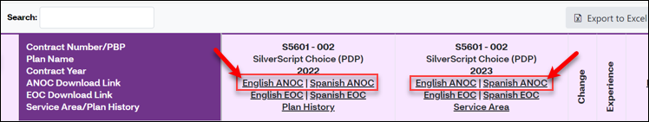

**Example**: ANOC

* Enter your Aetna email (if applicable).

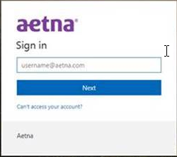

**Result**: You will be able to access these documents.

Top of the Document

|  |
| --- |
| Member Pharmacy Network |

To verify the Pharmacy network, refer to the SCP Tool chart:

**Note:** Enter your Aetna email if applicable.

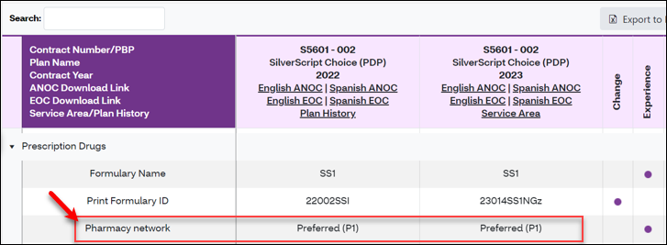

**Example**: Pharmacy Network

**Result**: You will be able to access these documents.

Top of the Document

|  |
| --- |
| Member EOC |

EOC links are built into the benefit grid.

* Access the EOC by clicking on the link for the EOC at the top without having to select a specific benefit.

**Note:** Enter your Aetna email if applicable.

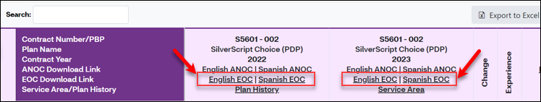

**Result**: You will be able to access these documents.

Top of the Document

|  |
| --- |
| Change & Experience Radial Dial |

* A radial dial in the **Change** column, these notate differences from the previous year.
* A radial dial in the **Experience** column, these notate a beneficiary impact.
* Educate the beneficiary as needed.

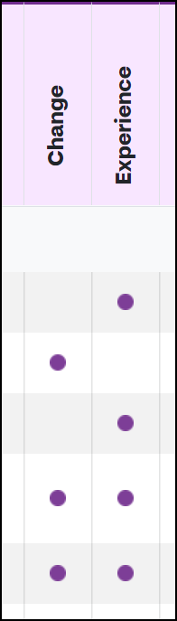

Top of the Document

|  |
| --- |
| Troubleshooting |

### Log In:

If you are unable to log in, do the following:

|  |  |
| --- | --- |
| **Step** | **Action** |
| **1** | Open the Chrome Cache window by pressing the ctrl, shift and delete buttons on your keyboard. |
| **2** | Check the boxes of the listed items. |
| **3** | Click the button titled, **Clear Browsing Data**. |
| **4** | Close all Google Chrome windows. |
| **5** | Open Google Chrome and follow the log on steps once again.  **Note:** Save this URL to your favorites.  For Chrome:   1. Click the star in the upper right corner of the browser. 2. Click **Done.** |

### Screen Resolution:

Screen resolution may affect how the SCP windows display. The recommended resolution is 100%. You can adjust this in Chrome by:

1. Click the three dots in the upper right corner of the browser window.
2. Click the + or – buttons to the right of **Zoom** to adjust as necessary.

Top of the Document

|  |
| --- |
| Related Documents |

**Parent SOP:** [CALL-0049](https://policy.corp.cvscaremark.com/pnp/faces/DocRenderer?documentId=CALL-0049)

**Abbreviations/Definitions:** Customer Care Abbreviations, Definitions and Terms

Top of the Document

Not To Be Reproduced Or Disclosed to Others Without Prior Written Approval

**ELECTRONIC DATA = OFFICIAL VERSION – PAPER COPY = INFORMATIONAL ONLY**